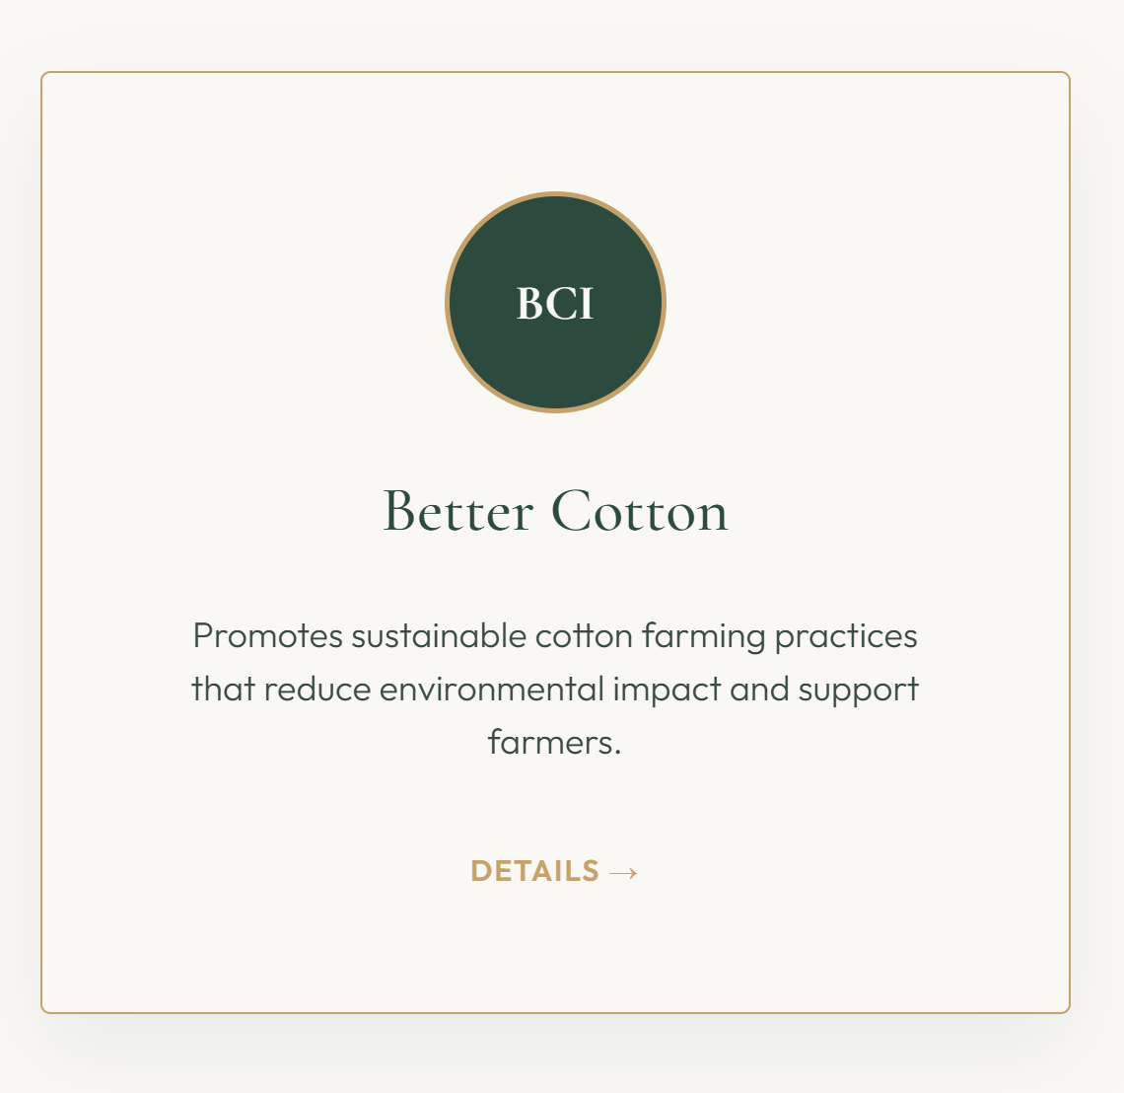

- In the Accreditation Page, Add the respective Logos in the circle. I have attached all the logos below.
- Below it write the full name of the Certification, instead of the short form. Kindly find the names below ,
- SA 8000 Standard 100
- Better Cotton Initiative
- Global Organic Textile Standard
- Global Recycled Standard
- Higg Index
- Oeko-Tex 100

\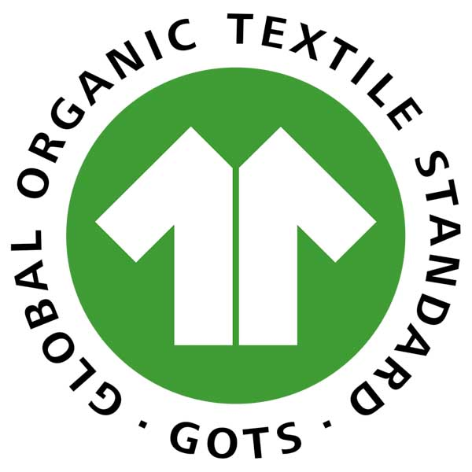 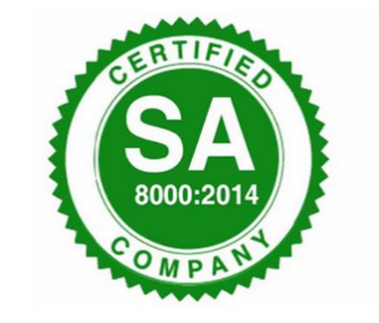

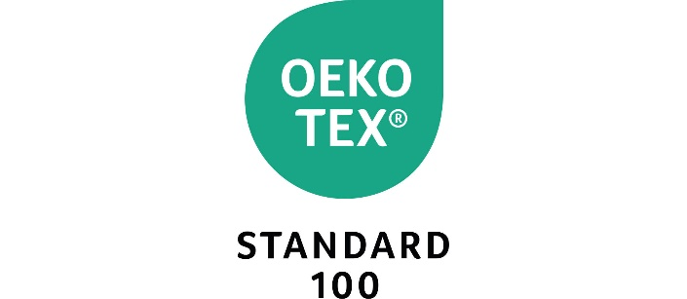
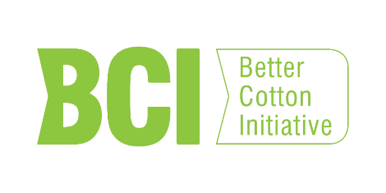

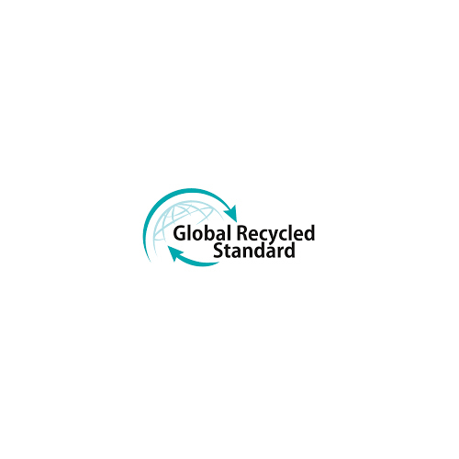
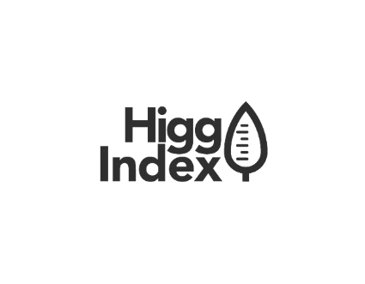

Cover Image for Accreditation Page:
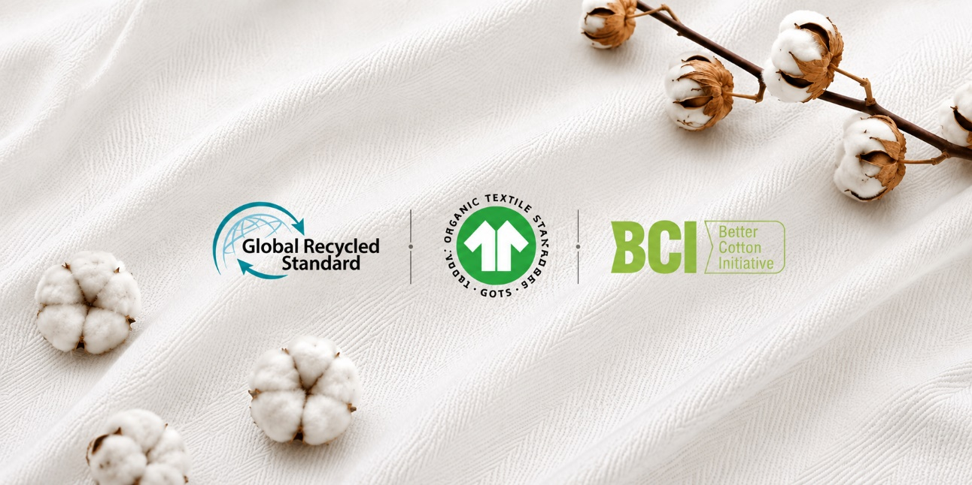
Cover Image for Infrastructure Page:
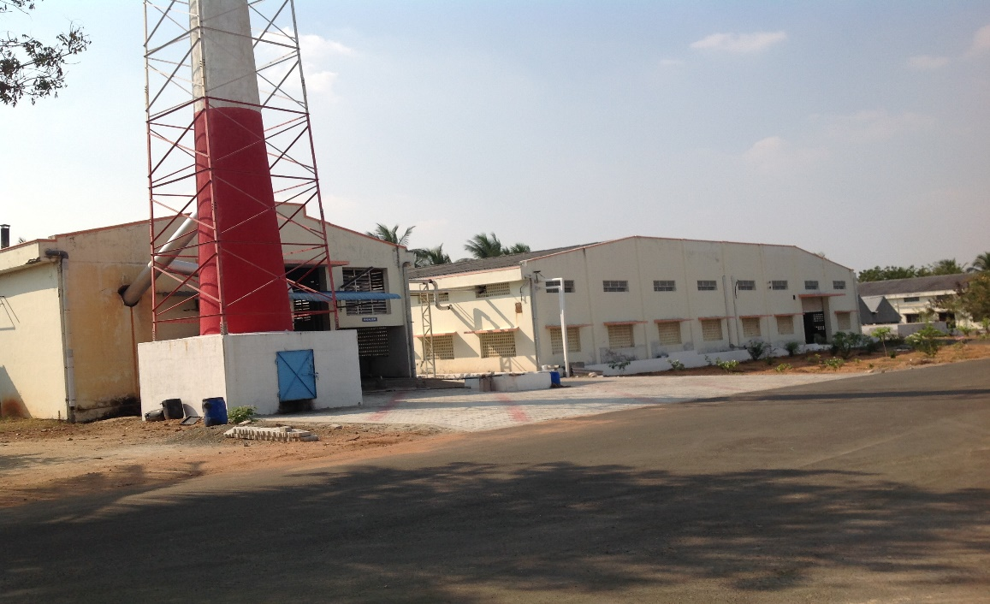

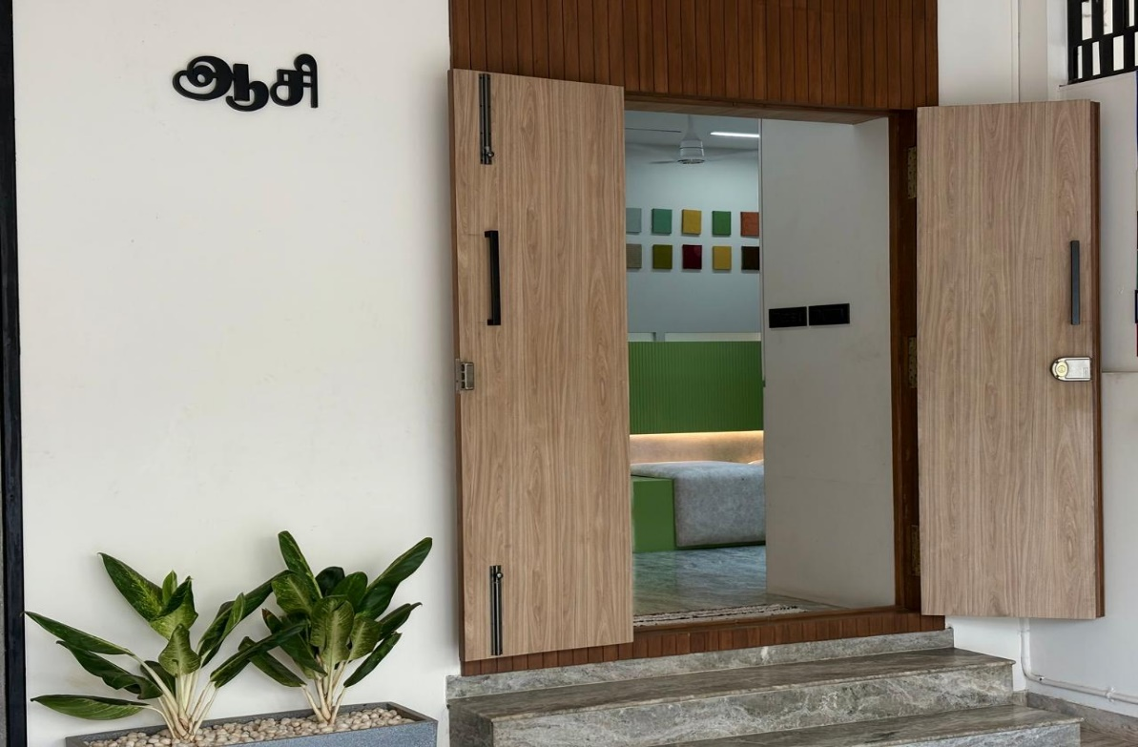
Cover Image for Contact Us Page:

Corrections in Images:
- Increase the height of these images a bit, if possible, keep the full view
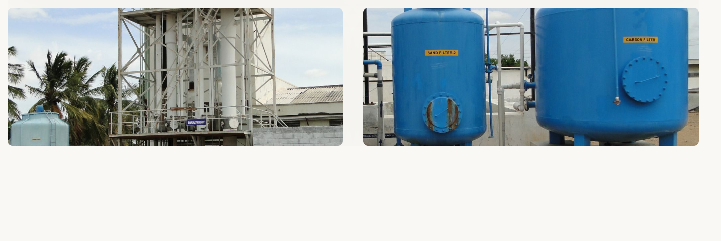

- In this, add the warping image as well. Make it same 3 layout image similar to other Process. Keep the top image same, add the warping image near Red Fabric weaving, also if possible show the full size for red fabric weaving

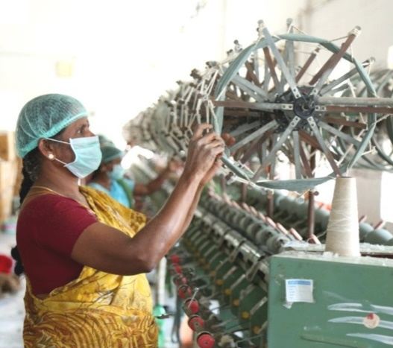
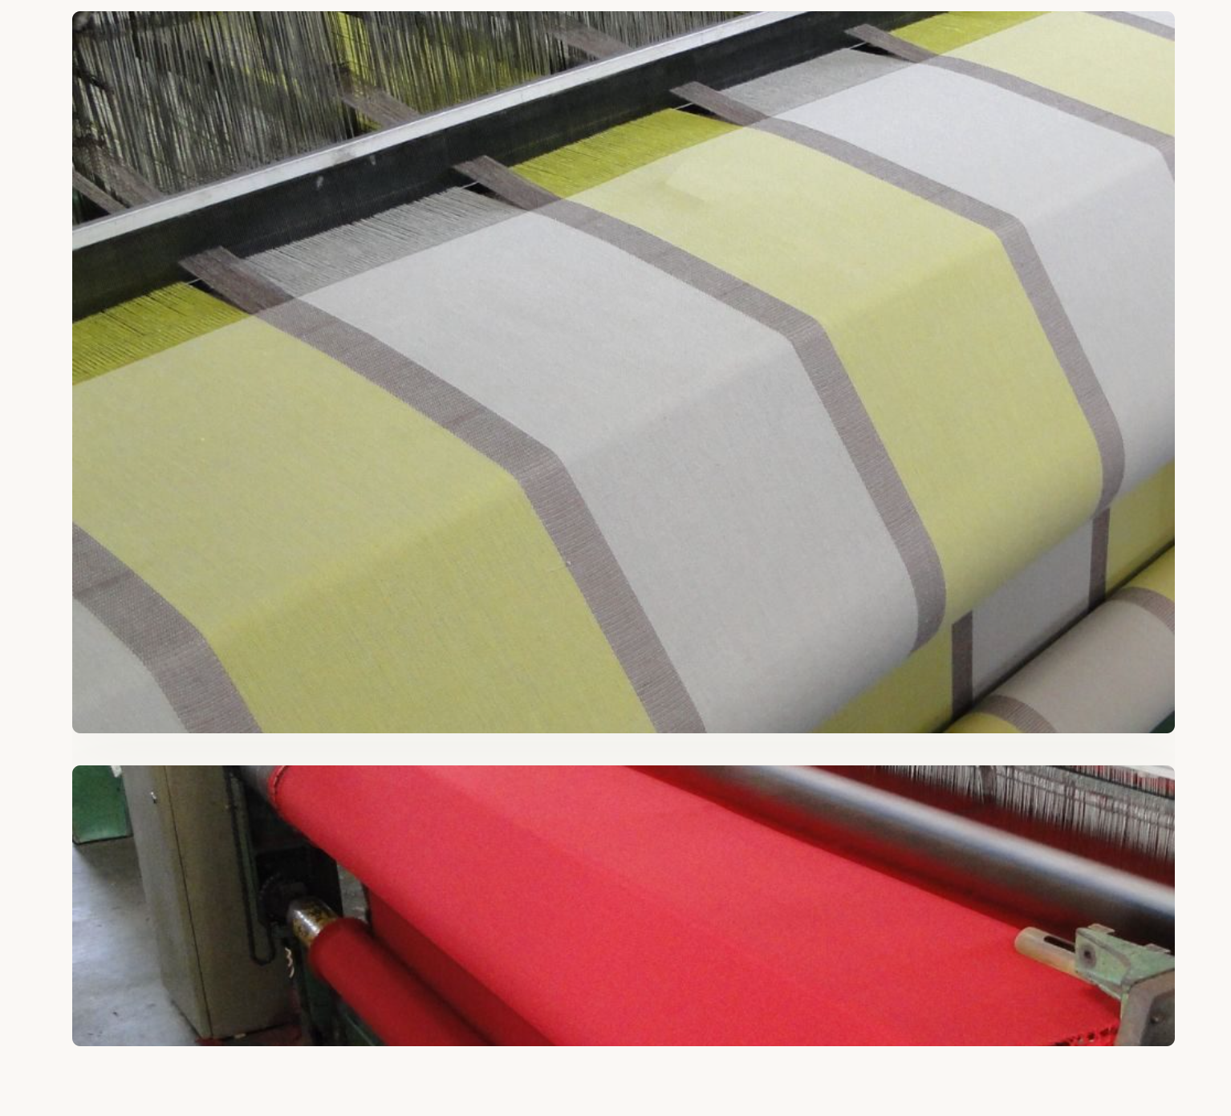

- In this, put the Ladies Checking image on the top, don’t cut that image show the ladies with face. Put the Pink shirt checking image down, in that pic cut of the bottom part, show only his shirt and above, crop off the dhoti
- In it’s content instead of 100% Quality Inspection and Packing, make it just “Quality Inspection and Packing”

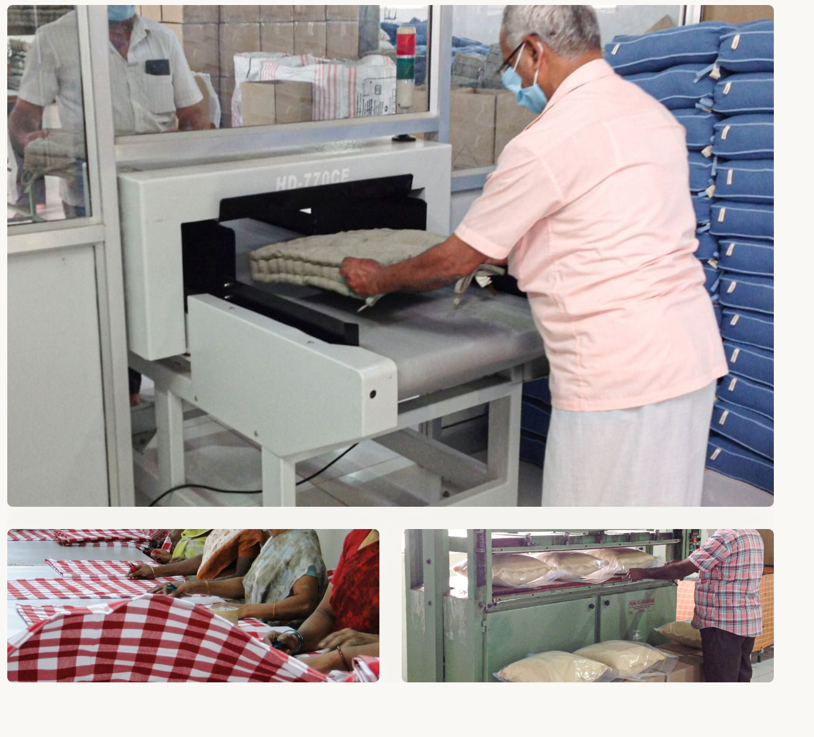

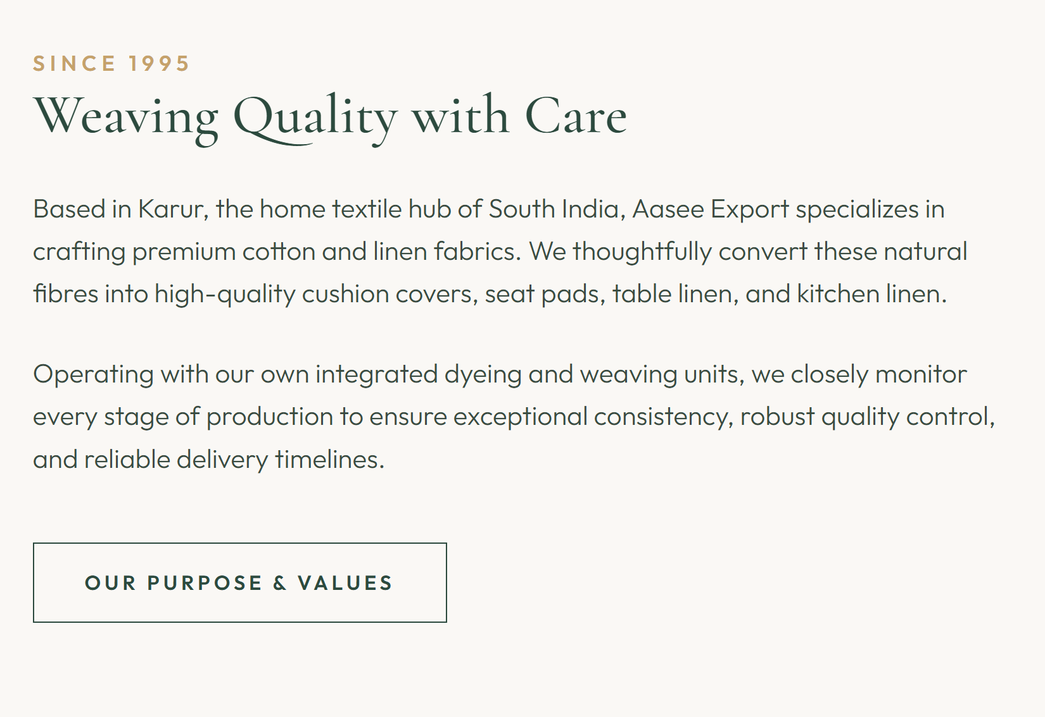
Instead of Natural Fibers, put “Fabrics”

